ShopNest Store

1. Introduction:
This Power BI capstone project analyzes the ShopNest Store dataset to uncover insights across sales performance, product ratings, customer geography, payment behaviour, and delivery efficiency. The goal was to build a single-page interactive dashboard that answers eight key business questions using calculated columns, DAX measures, and visual storytelling.

2. ETL Process:
Data Sources
There are totally 9 dataset csv files connected as tables.

- Nexusgoods_orders_dataset: order lifecycle and timestamps.
- Nexusgoods_order_items_dataset: product-level pricing and freight.
- Nexusgoods_order_payments_dataset: payment types and values.
- Nexusgoods_order_reviews_dataset: customer ratings and feedback.
- Nexusgoods_products_dataset: product metadata and categories.
- Nexusgoods_customers_dataset: customer location and zip codes.
- Nexusgoods_sellers_dataset: seller location and zip codes.
- Nexusgoods_geolocation_dataset: latitude/longitude mapping.
- product_category_name_translation: English category names.
Cleaning & Transformation
- Removed nulls and replaced missing product_category_name with "Uncategorized".
- Renamed Tables Nexusgoods_orders_dataset
- Replaced Values for geo_location_city column from Nexusgoods_geolocation_dataset.
- Added Data Categories to column with geo-mapping inside maps wherever required.
- Created calculated columns:
  - Order_Year, Order_Month, Order_Quarter
  - Is_Approved, Is_Delivered, IsDelayed
- Created relationship instead of merging for category translation to enrich product metadata.
- Ensured consistent data types across each table.

3. Data Modeling:
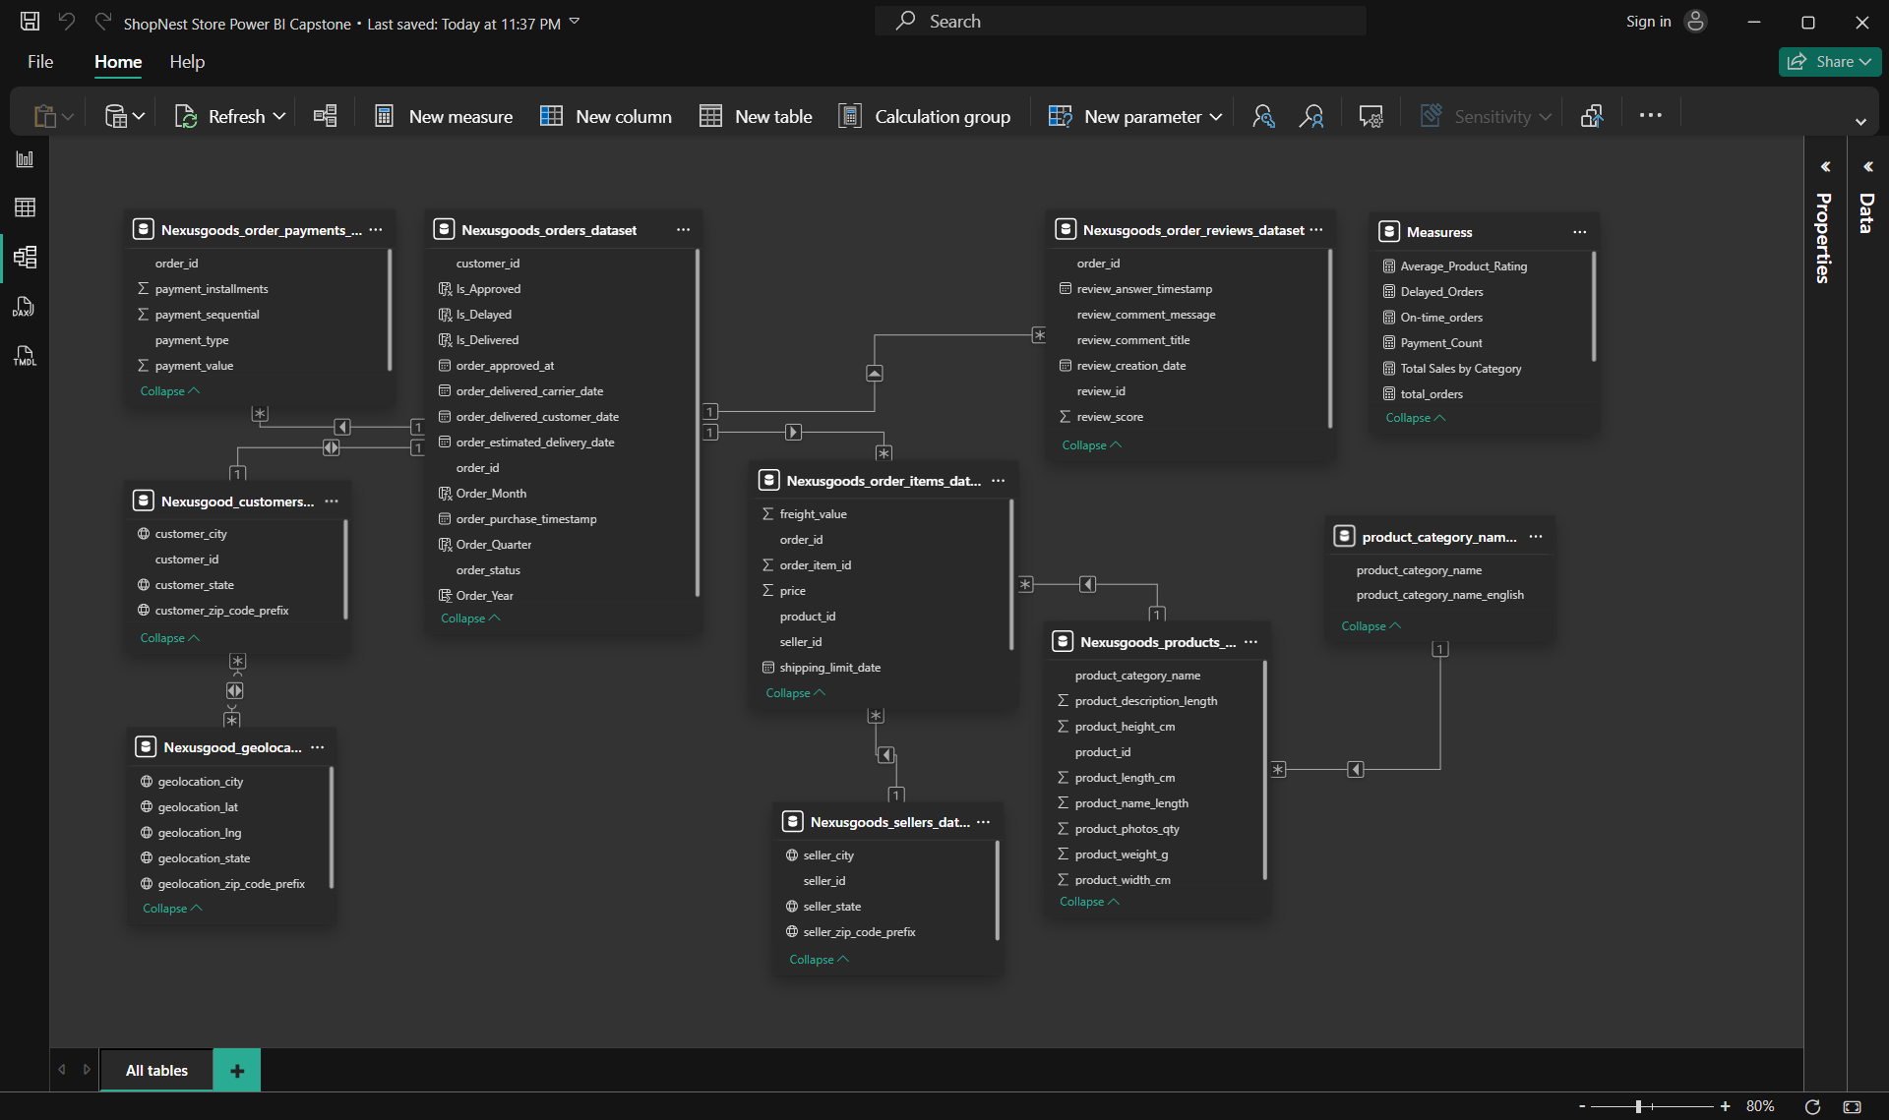
The model follows a star schema:
- Fact Tables: orders_dataset, order_items_dataset, order_payments_dataset, order_reviews_dataset
- Dimension Tables: products_dataset, customers_dataset, sellers_dataset, geolocation_dataset, product_category_name_translation
Relationships
- orders_dataset[order_id] → order_items_dataset[order_id]
- Nexusgoods_orders_dataset[order_id] → Nexusgoods_order_payments_dataset[order_id]
- Nexusgoods_orders_dataset[order_id] → Nexusgoods_order_reviews_dataset[order_id]
- Nexusgoods_order_items_dataset[product_id] → Nexusgoods_products_dataset[product_id]
- Nexusgoods_products_dataset[product_category_name] → product_category_name_translation[product_category_name]
- Nexusgoods_orders_dataset[customer_id] → Nexusgoods_customers_dataset[customer_id]
Almost all relationships are one-to-many with single-direction filtering.

4. Calculated Columns & DAX Measures:
Calculated Columns
- Order_Year = YEAR(Nexusgoods_orders_dataset[order_purchase_timestamp])
- Order_Month = FORMAT(Nexusgoods_orders_dataset[order_purchase_timestamp],"MMM YYYY")
- Order_Quarter = "Q" & FORMAT(Nexusgoods_order_purchase_timestamp, "Q")
- Is_Approved = IF(ISBLANK(Nexusgoods_order_approved_at), "Not Approved", "Approved")
- Is_Delivered = IF(ISBLANK(Nexusgoods_orders_dataset[order_delivered_customer_date]),"Pending","Delivered")
- Is_Delayed = IF(AND(Nexusgoods_orders_dataset[Is_Delivered] = "Delivered",Nexusgoods_orders_dataset[order_delivered_customer_date] > Nexusgoods_orders_dataset[order_estimated_delivery_date]),"Delayed","On-Time")

DAX Measures
- Total_Sales = SUM(Nexusgoods_order_items_dataset[price])
- Delayed_Orders = CALCULATE(COUNTROWS(Nexusgoods_orders_dataset),Nexusgoods_orders_dataset[Is_Delayed] = "Delayed")
- On-time_orders = CALCULATE(COUNTROWS(Nexusgoods_orders_dataset),Nexusgoods_orders_dataset[Is_Delayed] = "On-Time")
- Average_Product_Rating = AVERAGE(Nexusgoods_order_reviews_dataset[review_score])
- Payment_Count = COUNT(Nexusgoods_order_payments_dataset[payment_type])
- total_orders = COUNTROWS(Nexusgoods_orders_dataset)

5. Dashboard Design:
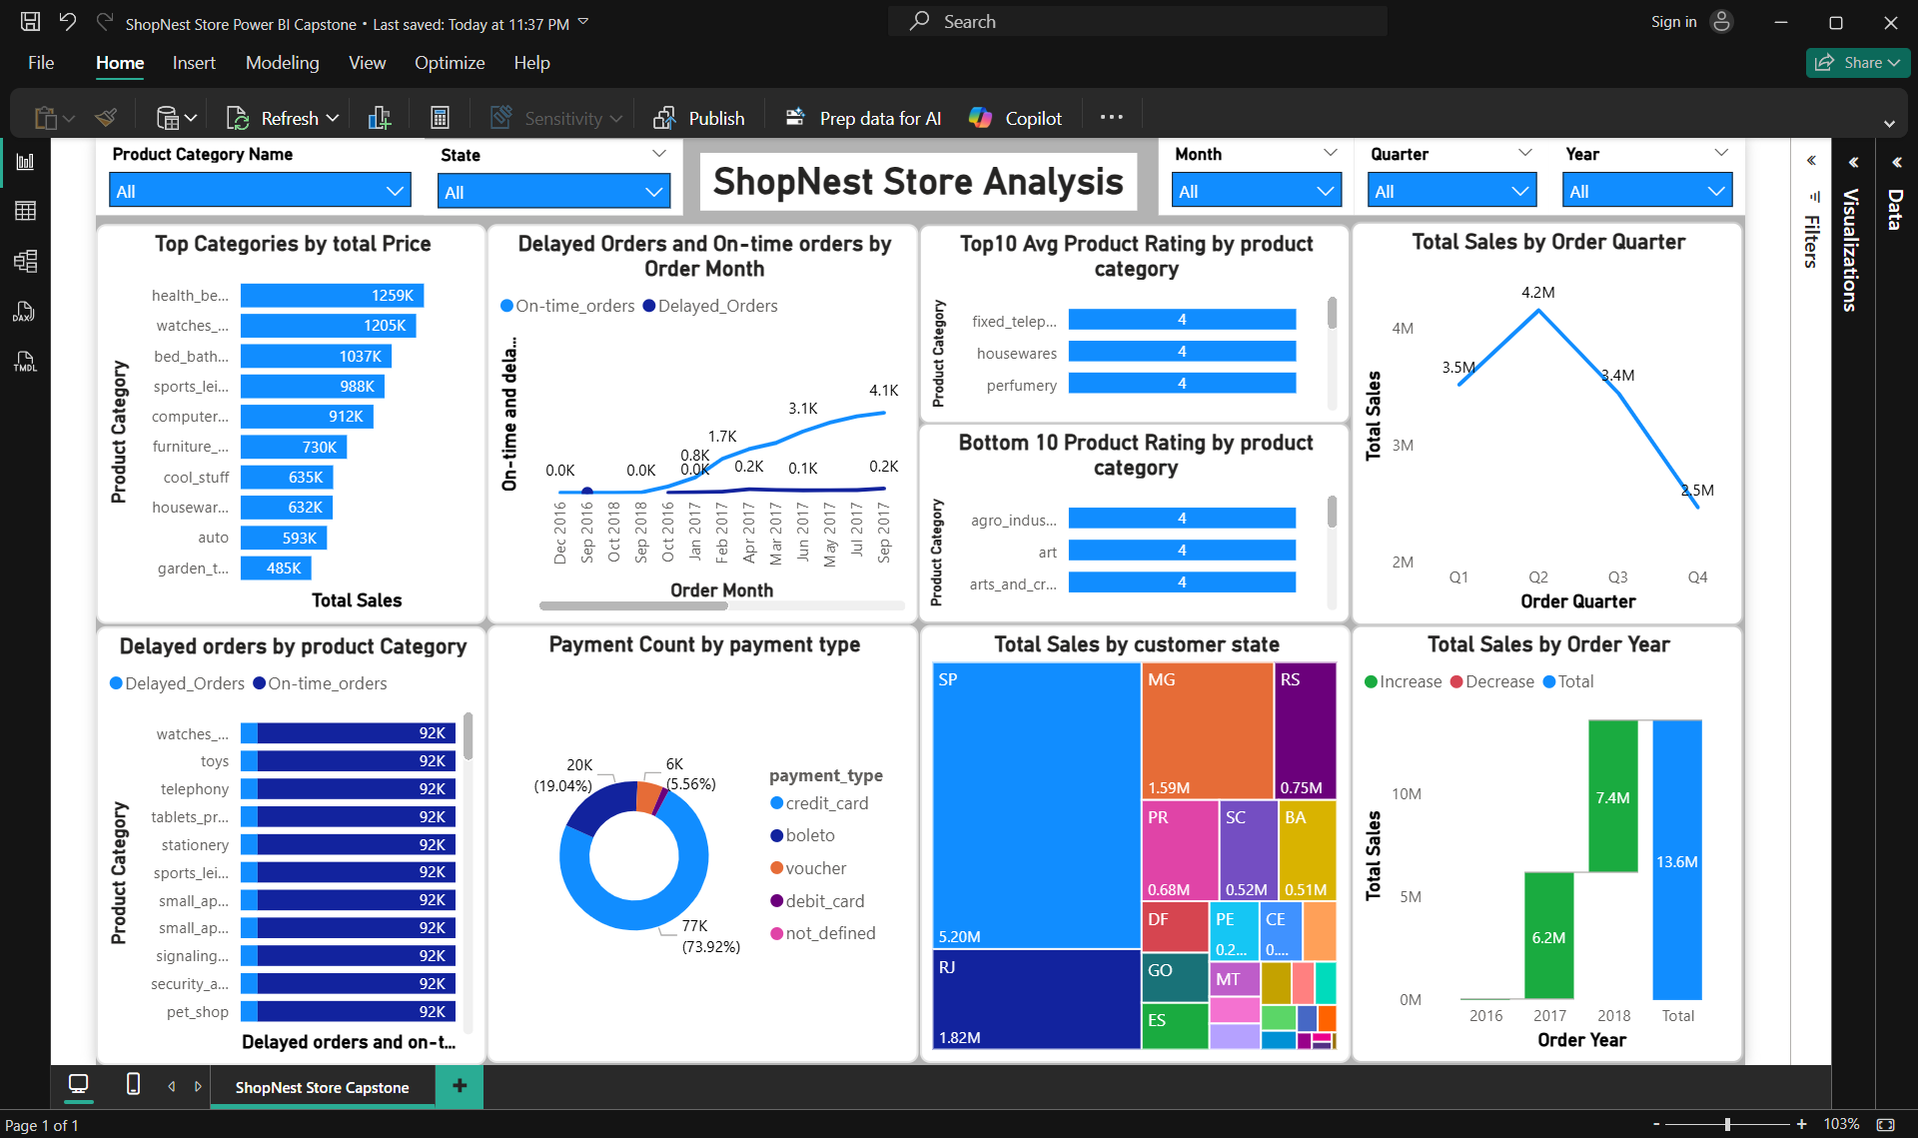
Layout
- Top Section: has filters and project name as Title.
- Main Body: 8 visualizations grouped by theme
Visual Types
- Bar Charts: Top Categories, Delayed Orders, Product Ratings
- Line Charts: Monthly Delays, Quarterly Sales, Yearly Revenue
- Donut Chart: Payment Type Distribution
- Treemap: Customer State Sales

6. Analysis of 8 Business Questions:
Q1: Top Categories by Total Price
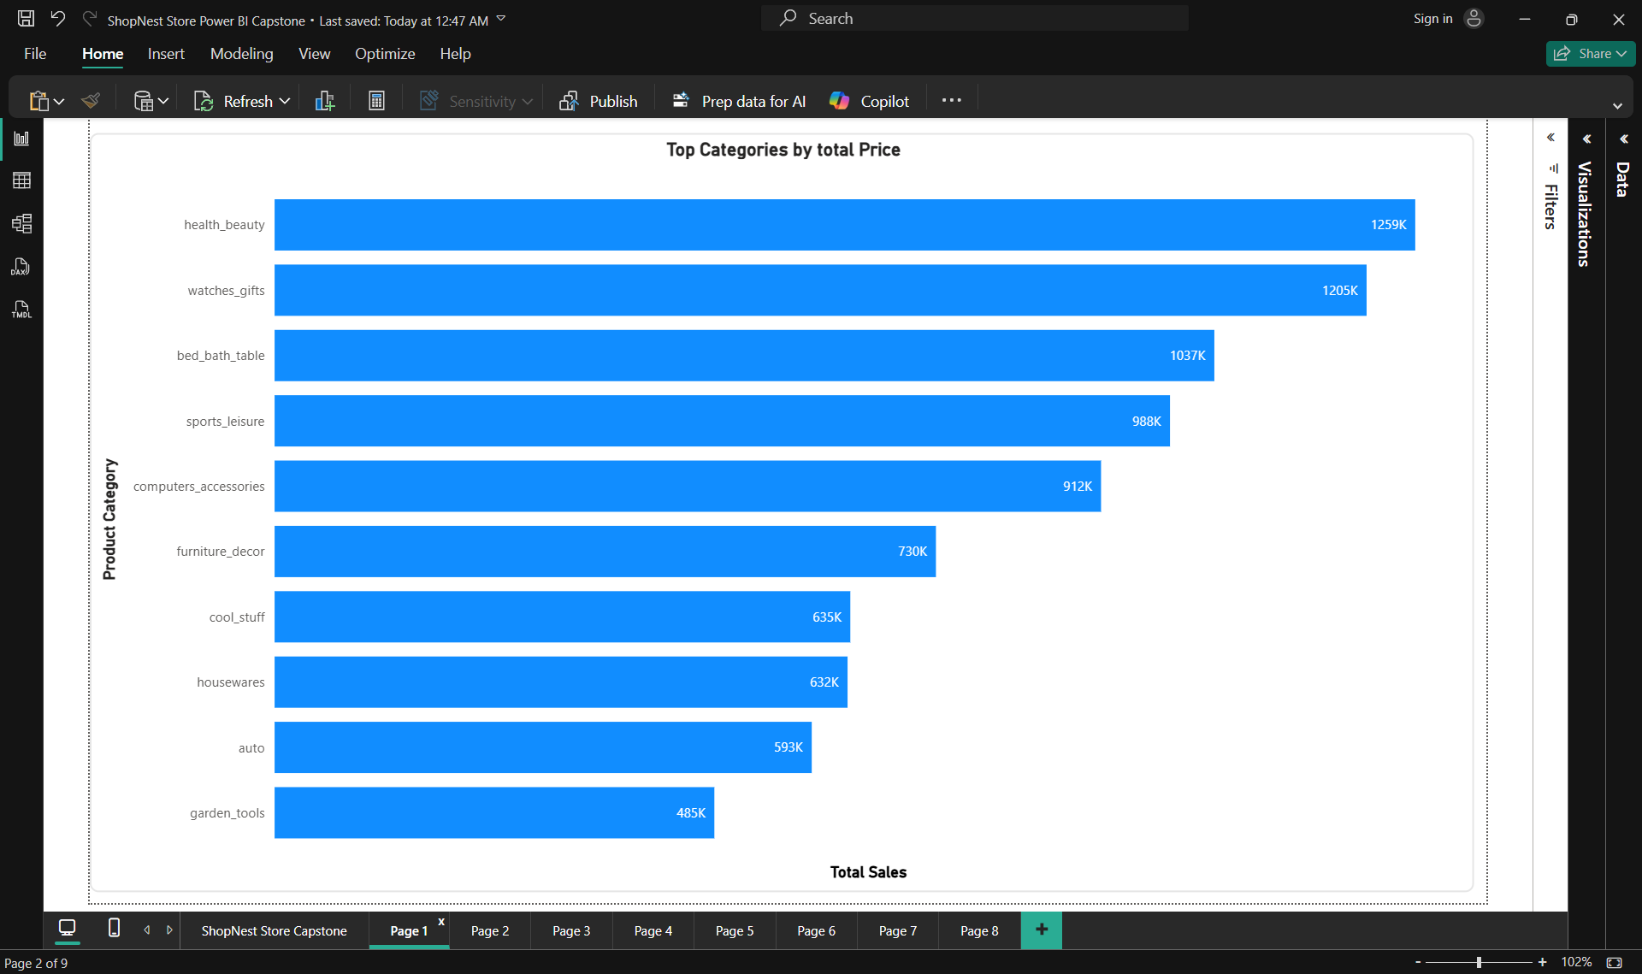
- Chart: Bar chart
- Axis: Product Category (English)
- Values: Total Sales
- Insight: Categories like health_beauty and watches_accessories dominate sales
Q2: Delayed Orders by Product Category
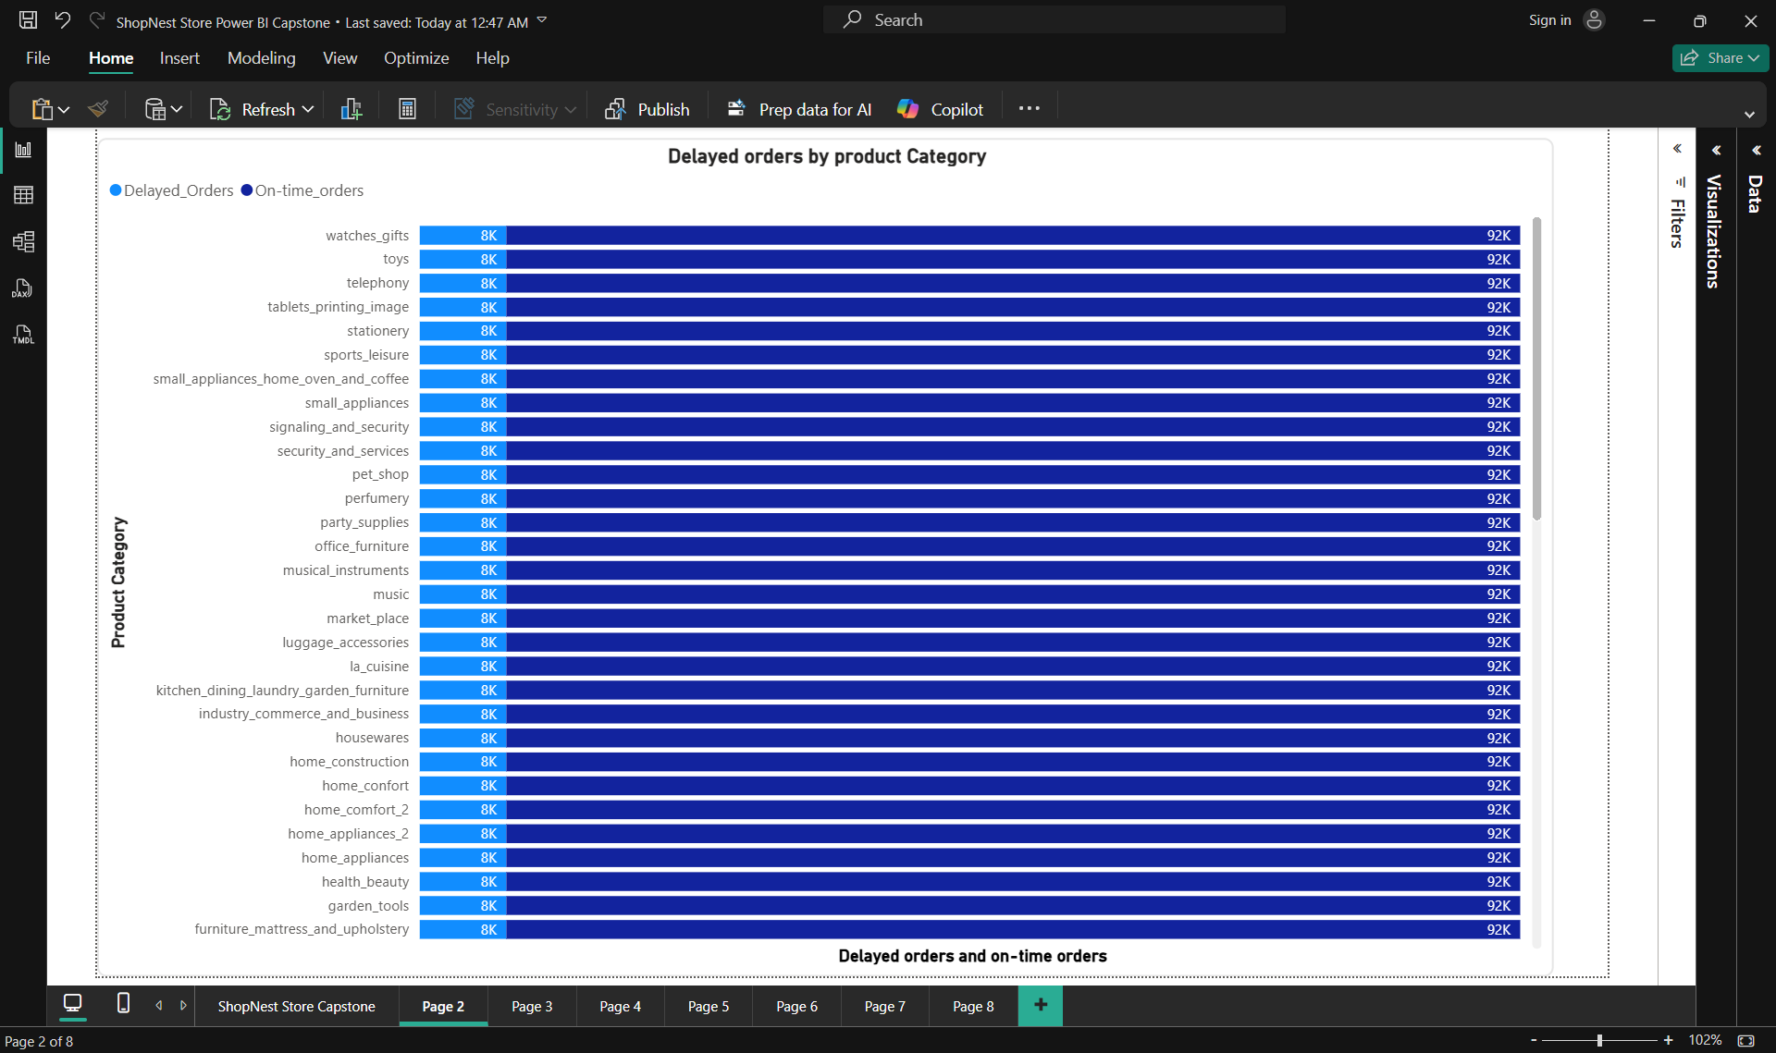
- Chart: Bar chart
- Axis: Product Category
- Values: Delayed Orders
- Insight: Categories like watches, toys, and telephony show high delay counts
Q3: Monthly Comparison of Delayed vs On-Time Orders
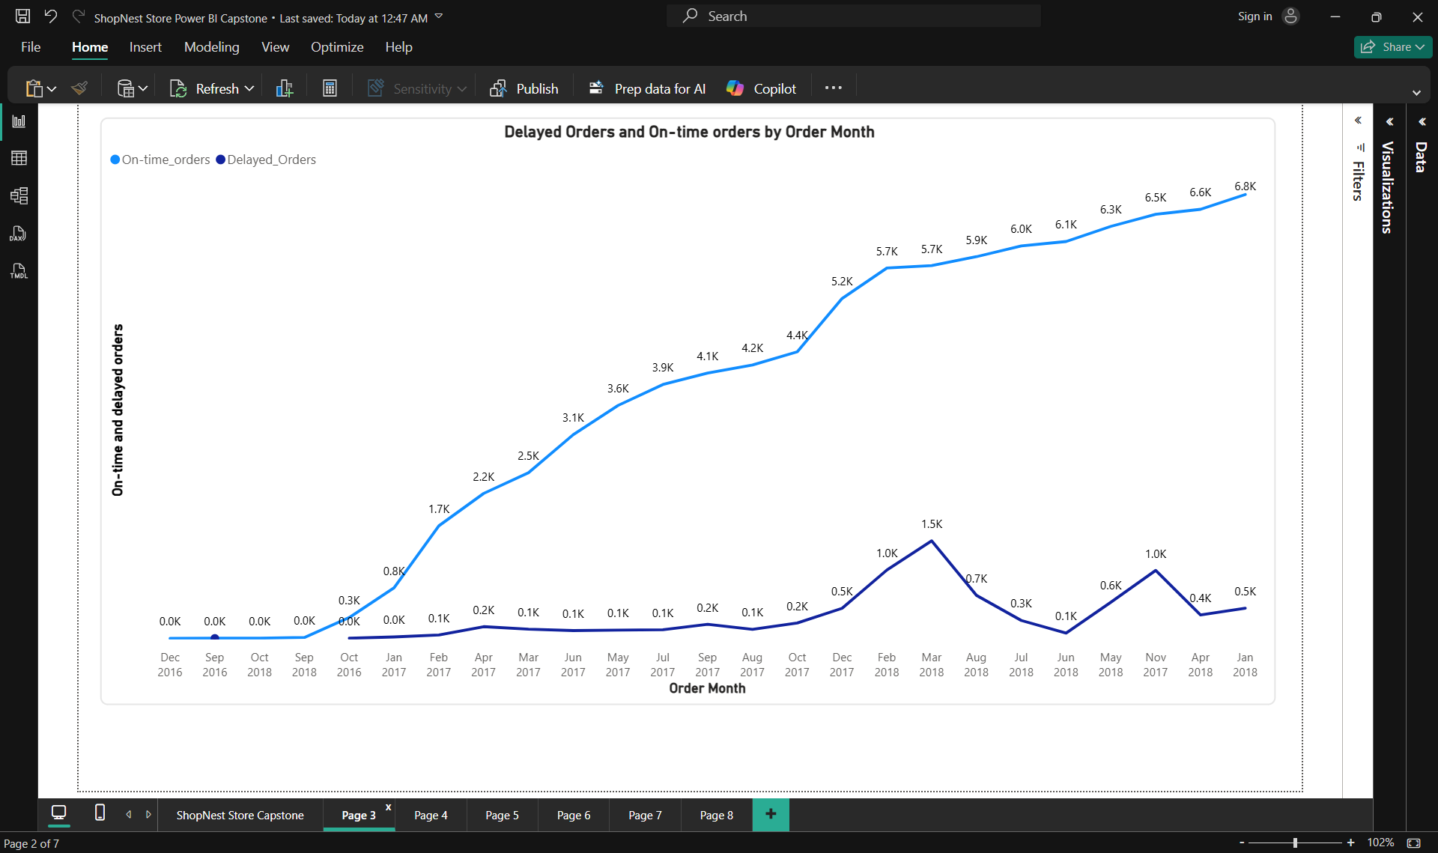
- Chart: Line chart
- Axis: Order Month
- Values: Delayed Orders, OnTime Orders
- Insight: Delay spikes in March and May 2017
Q4: Payment Method Analysis
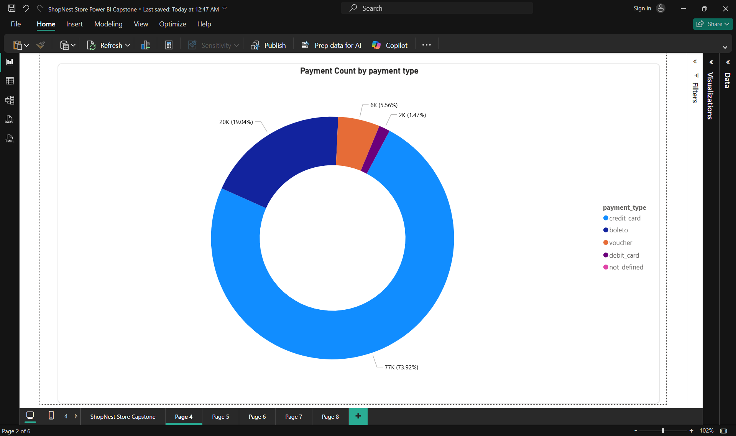
- Chart: Donut chart
- Legend: Payment Type
- Values: Payment Count
- Insight: Credit card dominates with 74% of transactions
Q5: Product Rating Analysis
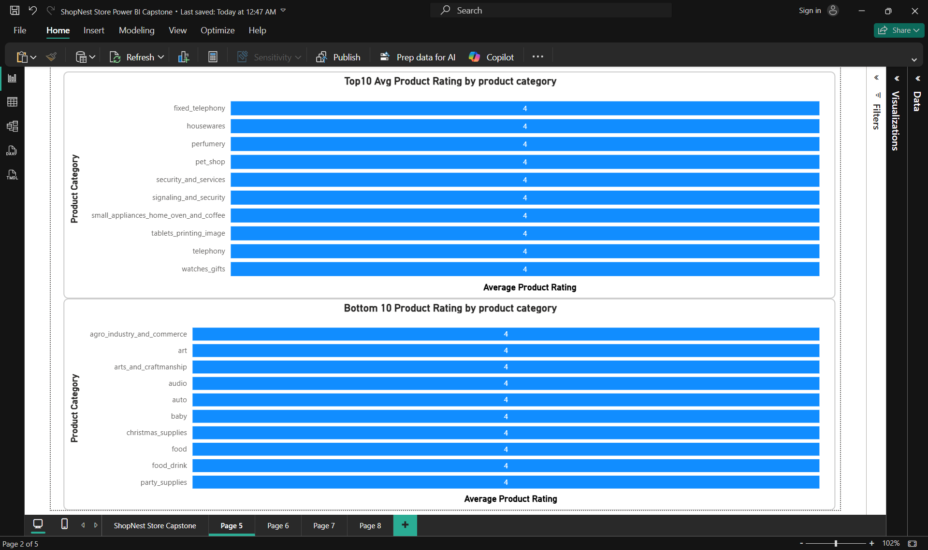
- Charts: Dual bar charts (Top 10 and Bottom 10)
- Axis: Product Category
- Values: Average Product Rating
- Insight: Categories like fixed_telephony and housewares have highest ratings; agro_industry and arts_and_crafts are lowest
Q6: State-wise Sales Analysis
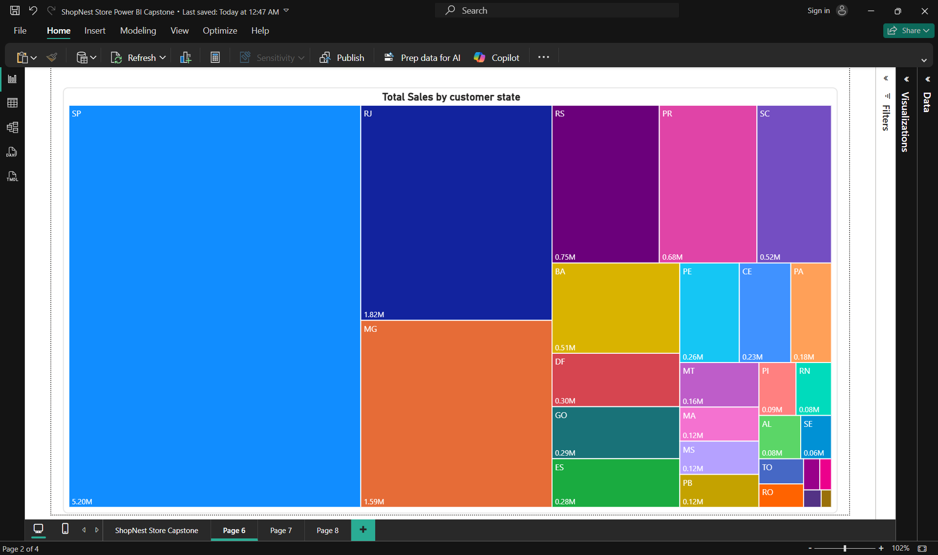
- Chart: Treemap
- Location: Customer State
- Values: Total Sales
- Insight: SP leads with ₹5.2M in sales, followed by RJ and MG
Q7: Seasonal Sales Patterns (Quarterly)
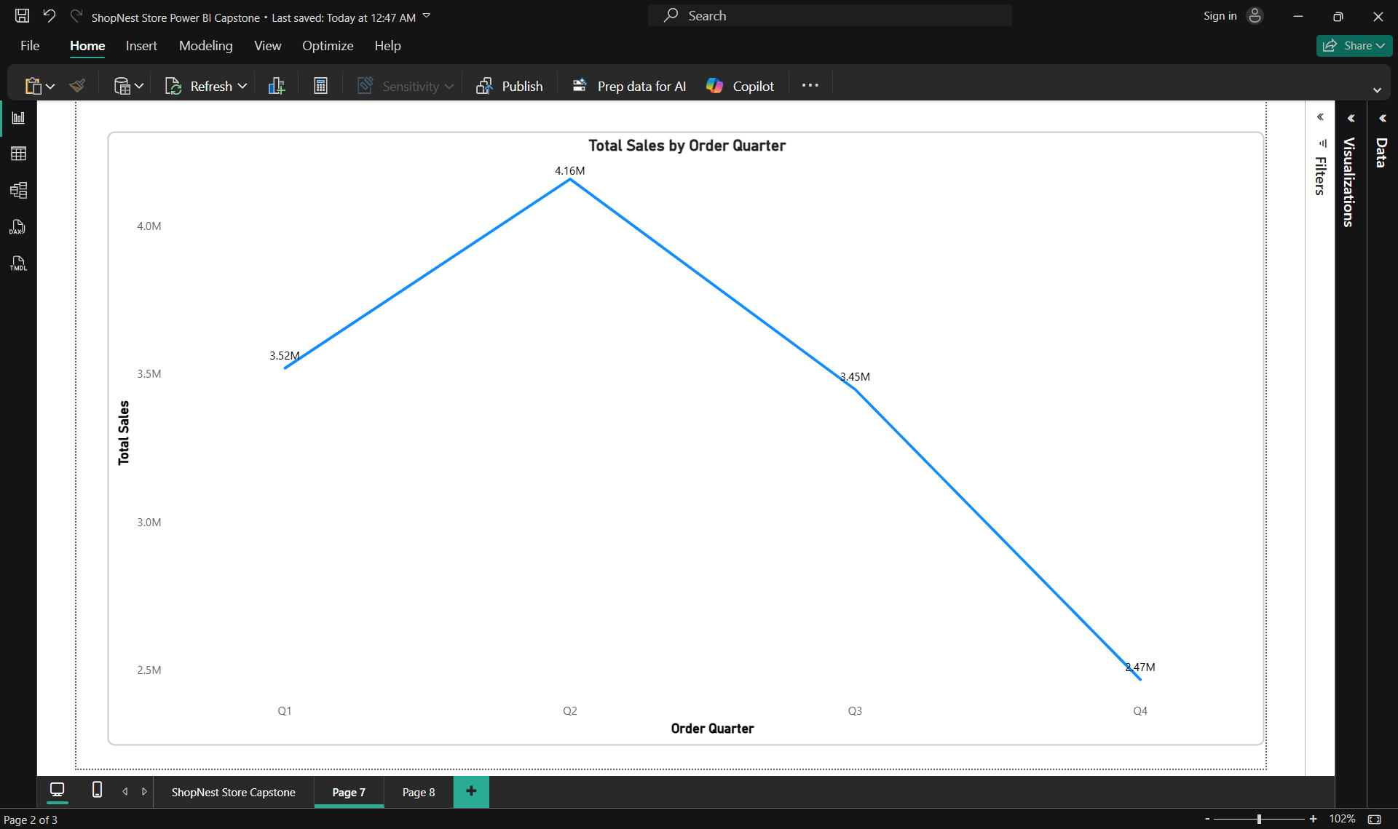
- Chart: Line chart
- Axis: Order Quarter
- Values: Total Sales
- Insight: Q2 shows peak sales at ₹4.2M
Q8: Revenue Analysis (Yearly)
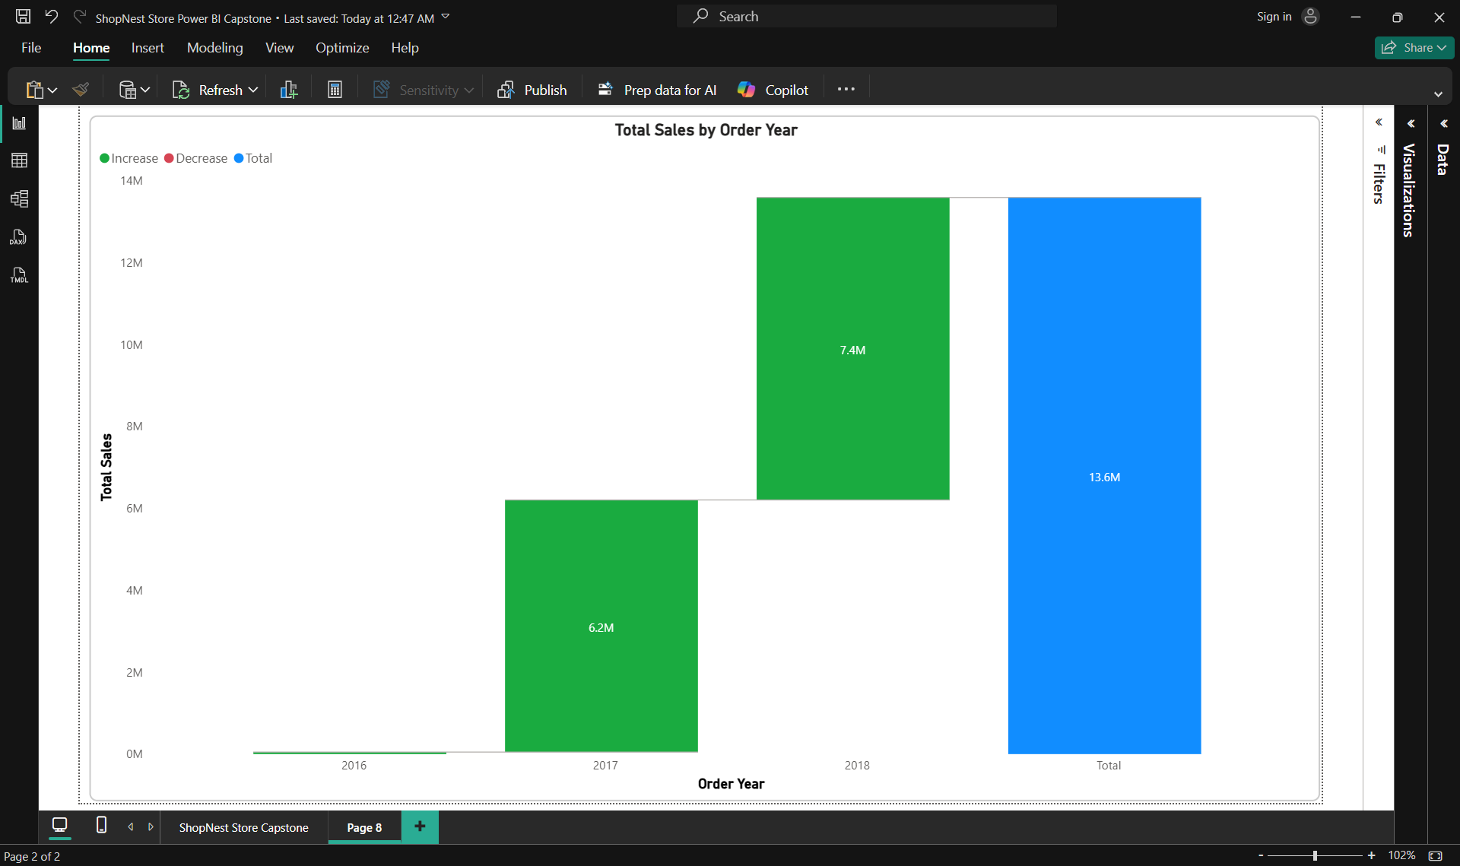
- Chart: Waterfall chart
- Axis: Order Year
- Values: Total Sales
- Insight: Revenue grew from ₹6.2M in 2016 to ₹13.6M in 2018

7. Slicers / Filters:
Slicers
- Product Category Name
- Customer State
- Order Month
- Order Quarter
- Order Year

8. Conclusion:
The ShopNest Store dashboard provides a comprehensive view of business performance across categories, geography, and time. Key findings include:
- High delays in specific categories suggest fulfilment issues
- Credit card is the dominant payment method
- Seasonal peaks in Q2 and strong revenue growth in 2018
- Top-rated products can be promoted for customer satisfaction
This dashboard enables stakeholders to make data-driven decisions to improve logistics, marketing, and customer experience.

9. Appendix
DAX Formulas
- See Section 4 for all calculated columns and measures
Power Query Steps
- Column renaming
- Null replacement
- Replacing values
Challenges Solved
- Blank categories resolved via relationship correction
- Top/Bottom N filtering clarified with visual-level filters
- Dual chart layout implemented for rating comparison

End of Report

